Algebra 1: Unit 13, Lesson H2

- Consider the functions $K(x)$ and $H(x)$.
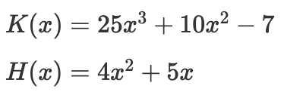
Write an expression that is equivalent to $K(x)⋅H(x).$
$$100x^{5}+165x^{4}+50x^{3}-28x^{2}-35x$$

- Two functions are shown.
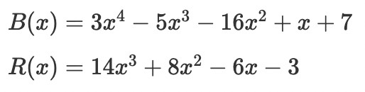
Find $B(x)+R(x).$
$$3x^{4}+9x^{3}-8x^{2}-5x+4$$

- Consider the functions $B(x)$ and $R(x)$.
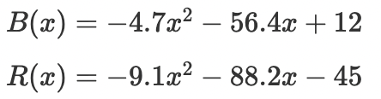
Write an expression that is equivalent to $R(x)-B(x)$.
$$-4.4x^{2}-31.8x-57$$

